Assignment 2

# 20BCE7273 Sahishnu Aprameya

## File and Directory Manipulation:

1. Create a directory called “my_directory”.  
   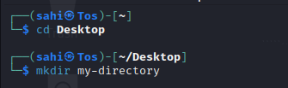
2. Navigate into “my_directory”.  
   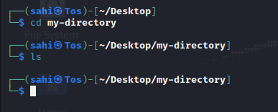
3. Create an empty file called "my_file.txt".  
   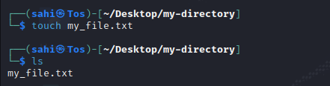
4. List all the files and directories in the current directory.  
   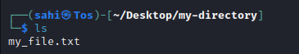
5. Rename "my_file.txt" to "new_file.txt".  
   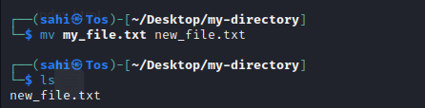
6. Display the content of "new_file.txt" using a pager tool of your choice.  
     
   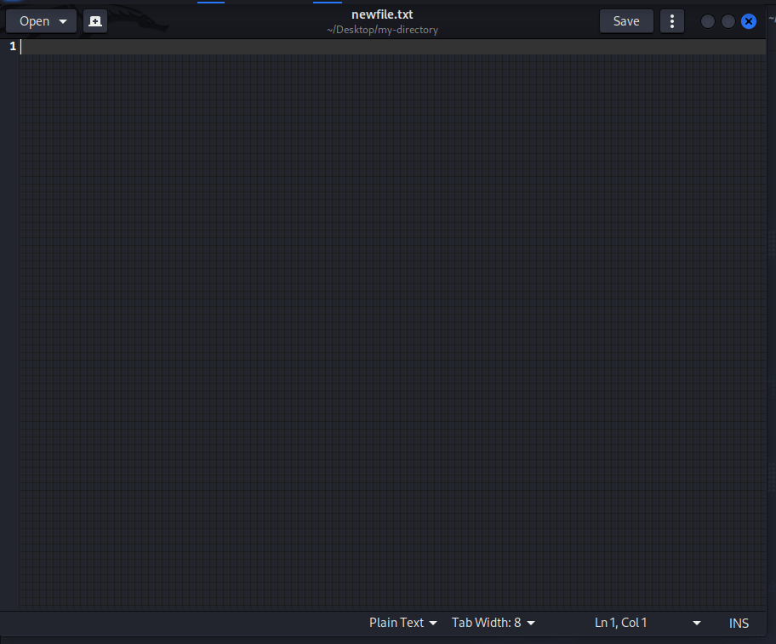
7. Append the text "Hello, World!" to "new_file.txt".  
   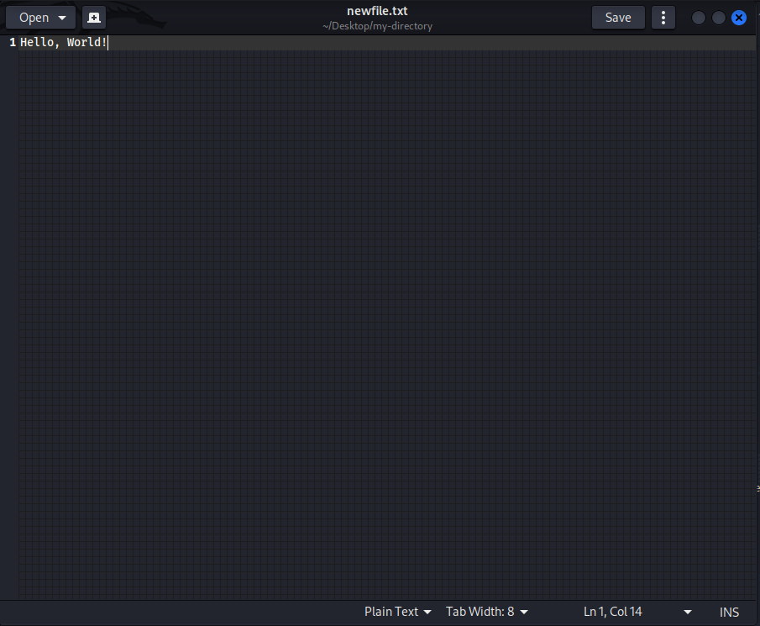
8. Create a new directory called "backup" within "my_directory".  
   
9. Move "new_file.txt" to the "backup" directory.  
   
10. Verify that "new_file.txt" is now located in the "backup" directory.  
    
11. Delete the "backup" directory and all its contents.  
    

## Permissions and Scripting:

* Create a new file called "my_script.sh".
* Edit "my_script.sh" using a text editor of your choice and add the following lines:

**bash**

**#!/bin/bash**

**echo "Welcome to my script!"**

**echo "Today's date is $(date)."  
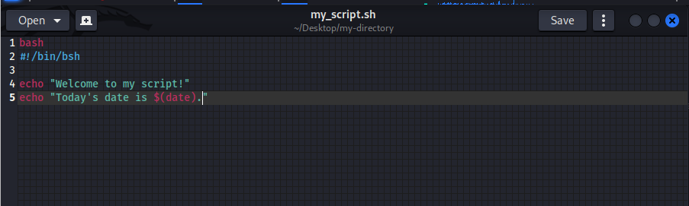**

* Make "my_script.sh" executable.  
  
* Run "my_script.sh" and verify that the output matches the expected result.  
  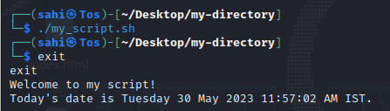

## Command Execution and Pipelines:

* List all the processes running on your system using the "ps" command.  
  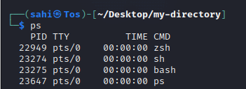
* Use the "grep" command to filter the processes list and display only the processes with "bash" in their name.  
  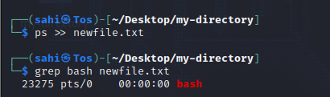
* Use the "wc" command to count the number of lines in the filtered output.  
  